Instructions for Installing CommentarySandbox Plugin

On your Wordpress site…

1. **After login to dashboard, select the Plugins menu:**

**C:\Users\my\Desktop\Manage_Themes_‹_commentpress_—_WordPress_-_2016-12-29_12.07.33.png**

1. **In the Plugins menu, select “Add New”:** [Note: if you are in a Network Wordpress site, the Plugin may need to be added in the Network Admin Dashboard]

**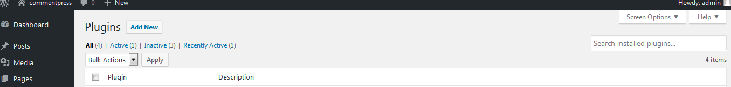**

1. **Upload the plugin CommentarySandbox.zip 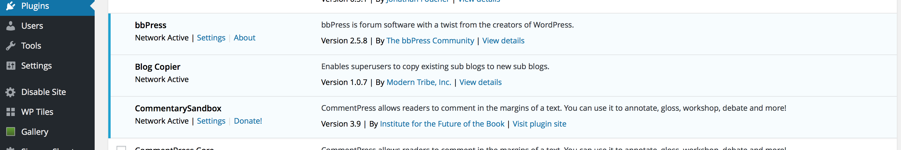**
2. **Select “Settings” and Activate the plugin by checking the “Activate CommentPress” checkbox**

**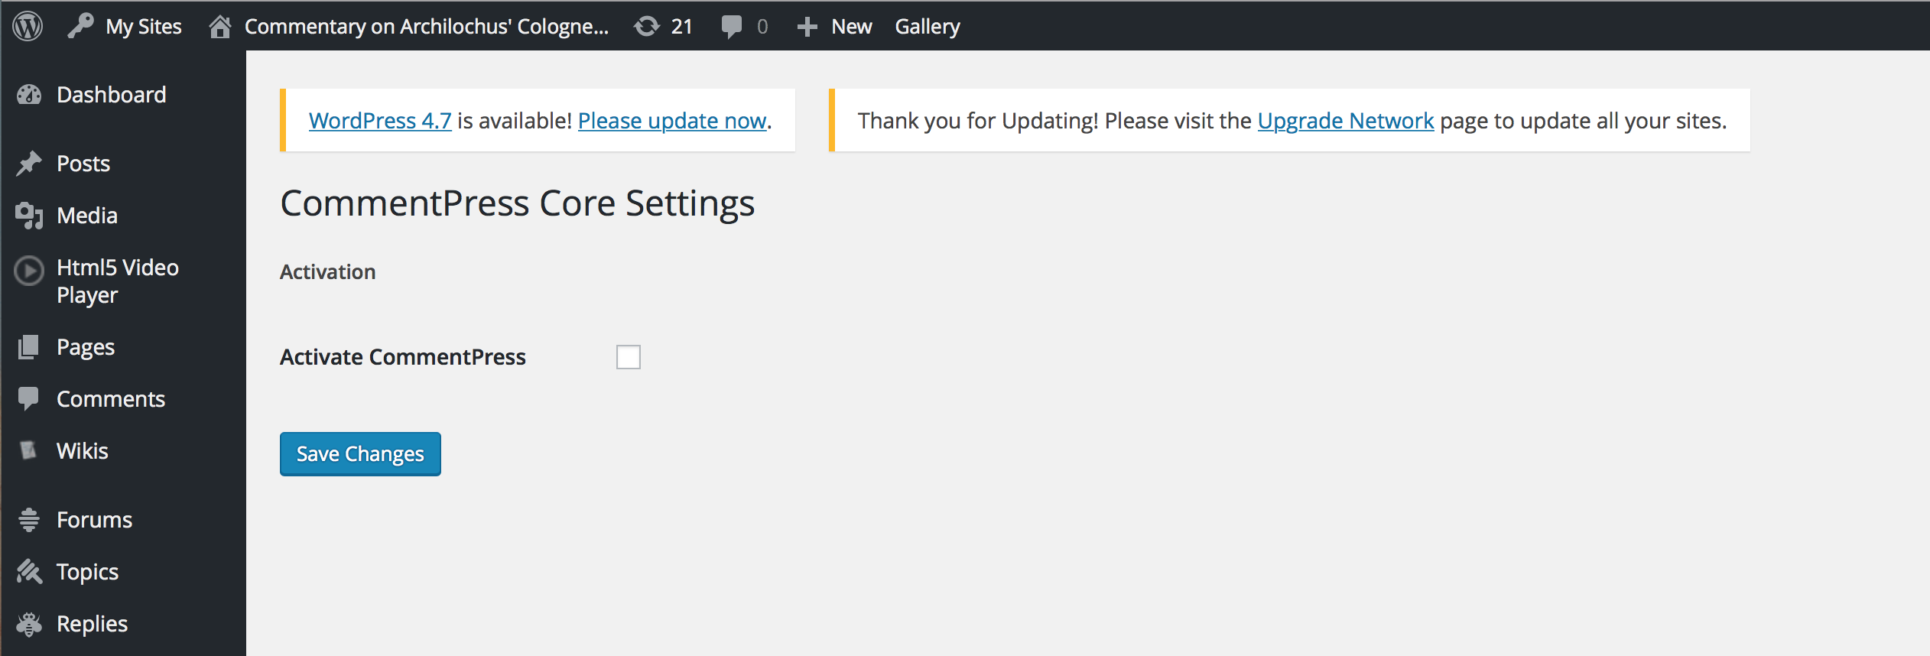**

1. **After successful installation and activation of plugin. You can now modify or create pages:**

**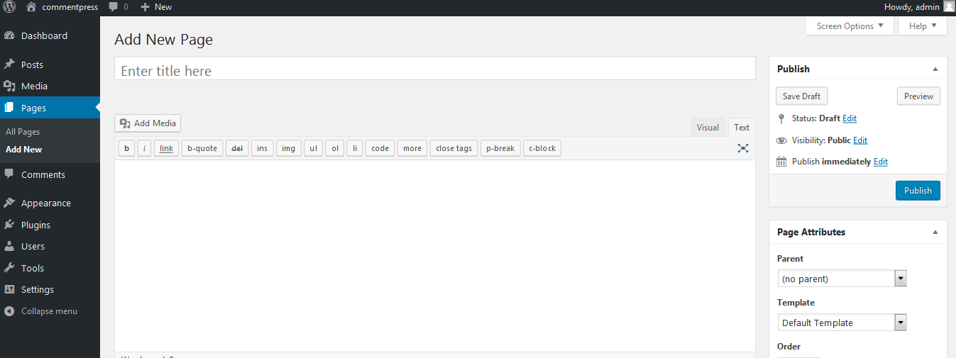**

1. **If you don’t see custom fields below the WYSIWYG editor, click on screen options dropdown arrow at the top of the page and check “Custom Fields”:**

**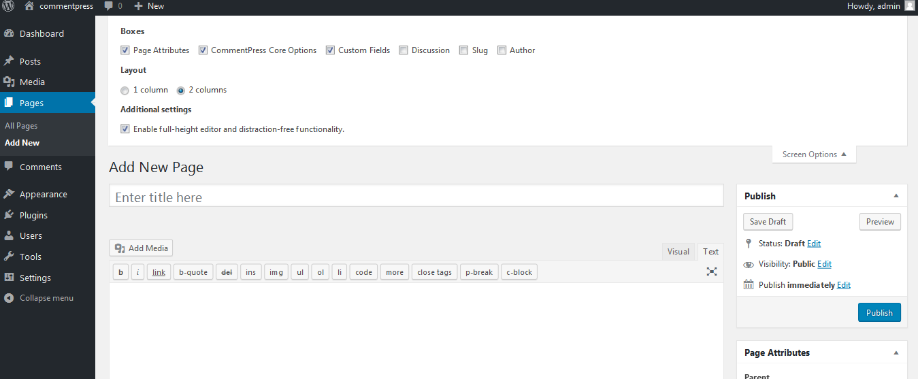**

1. **After checking the “Custom fields” options, custom fields section will be visible underneath the WYSIWYG editor here:**

**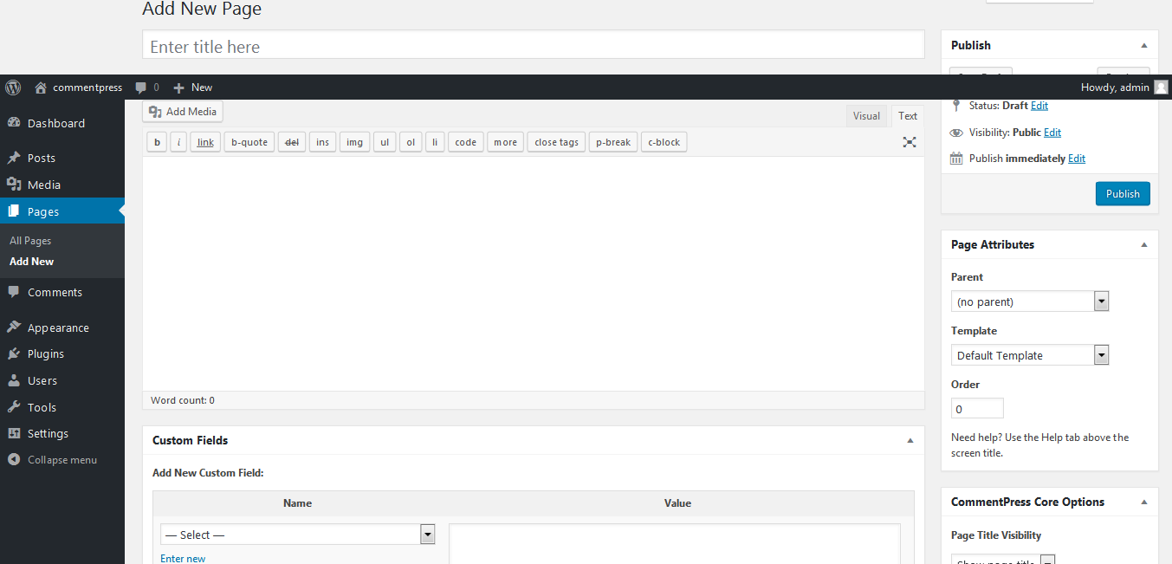**

1. **You will use these to create the “Notes” and “Vocabulary” fields:**

**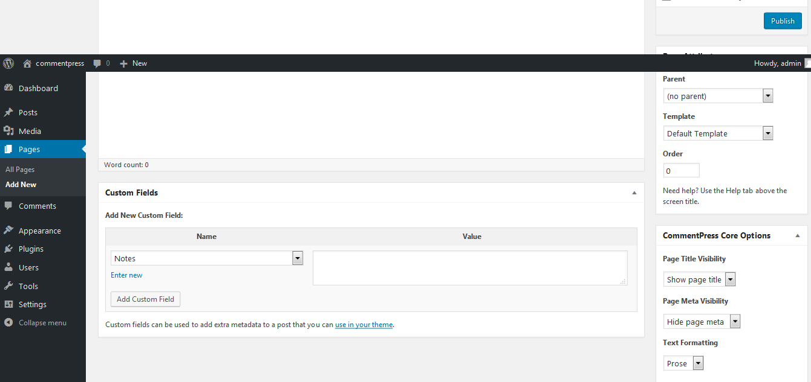**

1. **If you want to create new custom field click here:**

**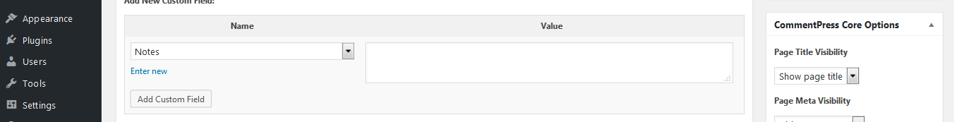**

**When you create your first commentary page, you will need to add the “Notes” and “Vocabulary” fields. To do this, simply select “Enter new” below the “Name” drop-down box**

**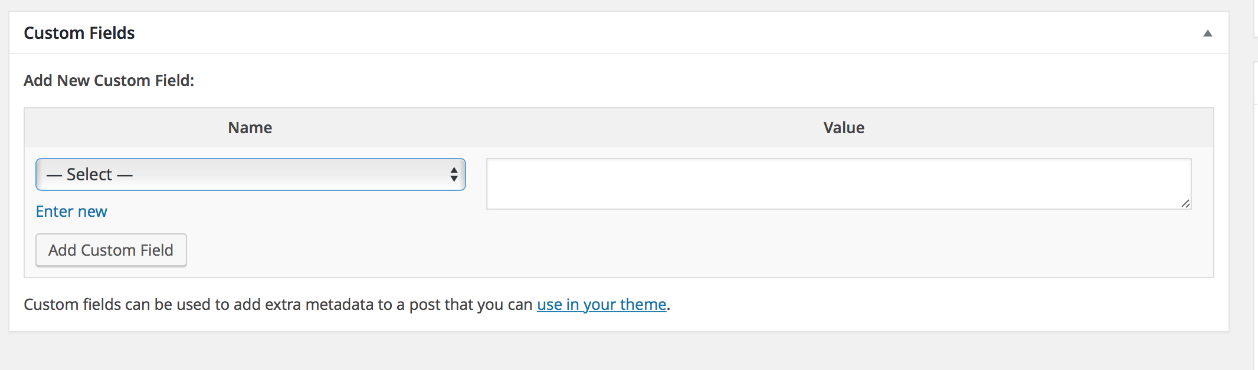**

**Type “Notes” in the Name field, enter some text in the Value field (you can edit this easily later, but to create the field you must enter something in the Value field)**

**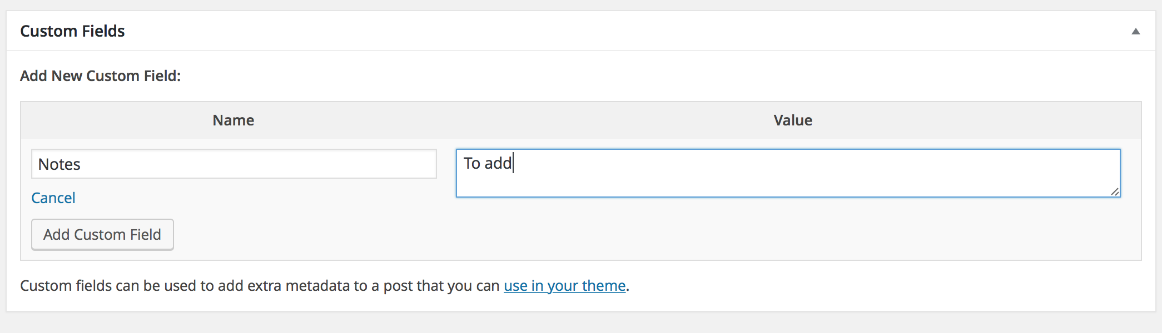**

**Repeat to make a “Vocabulary” field:**

**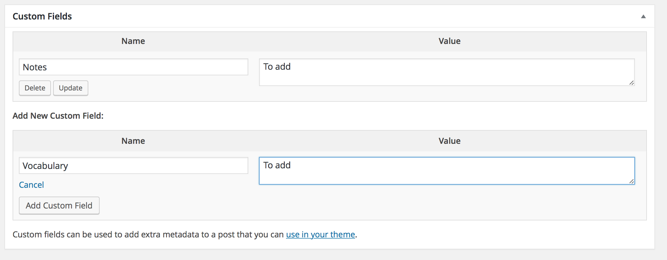**

**Note: Pages without “Notes” And “Vocabulary” fields remain on full width. These are useful for Introduction, etc.**

**10) When you create your second page, Notes and Vocabulary will appear in the Name drop-down list**

**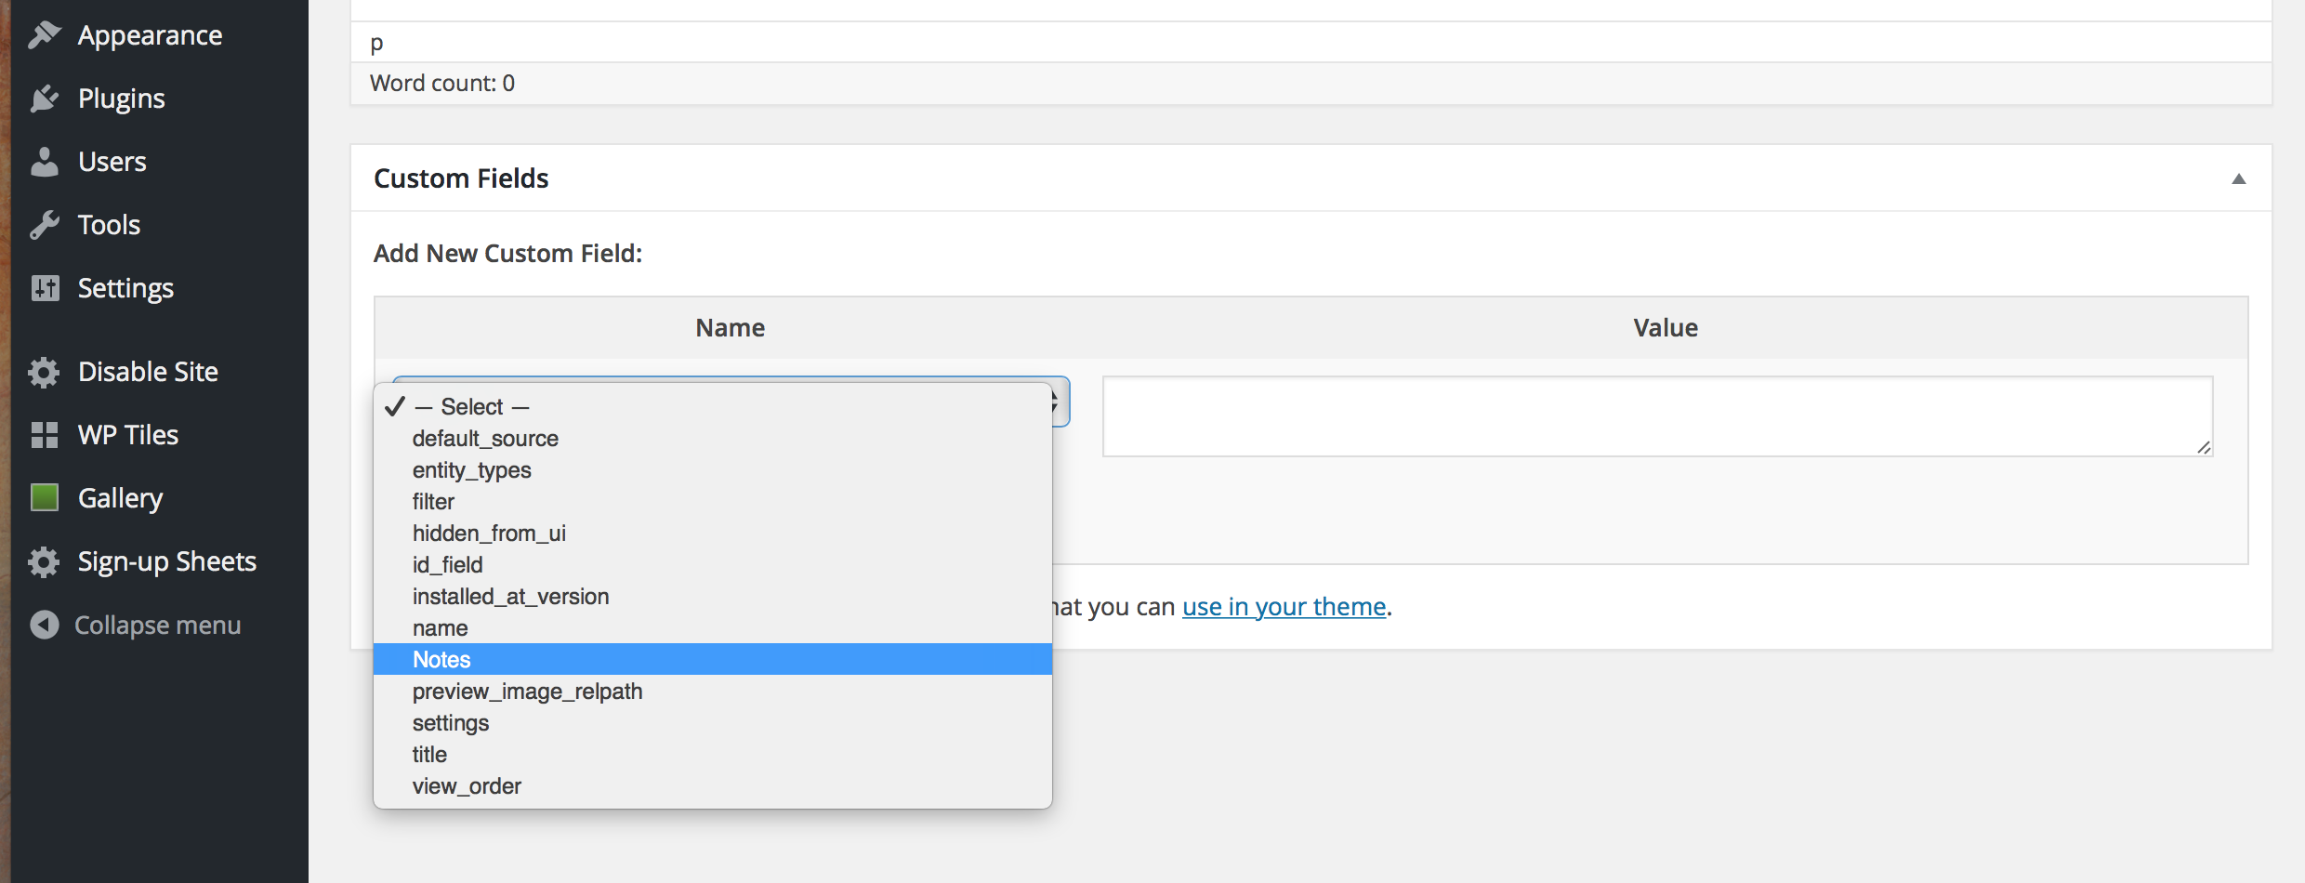**

**11) You can Customize the “Navigation” Menu using the Menus menu under Appearance**

**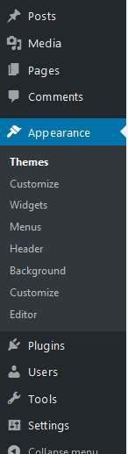**

1. **Arrange the components of the menu as you wish and then select “Create Menu”:**

**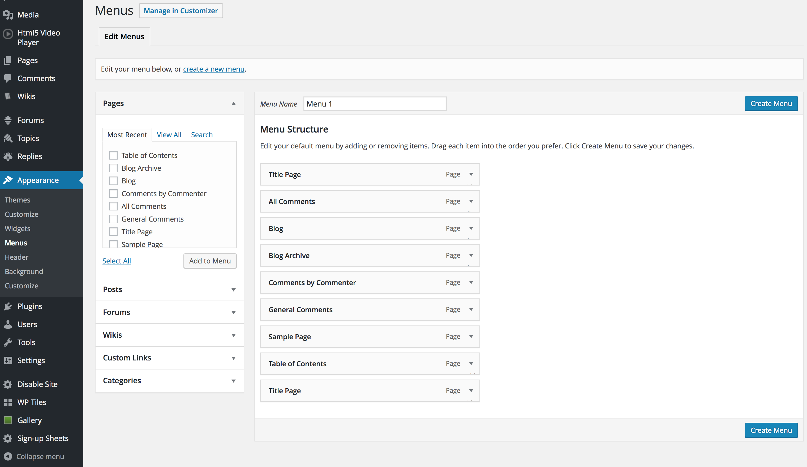**

**(13) After creating menu, select the “Manage Locations” tab in the Menus menu**

**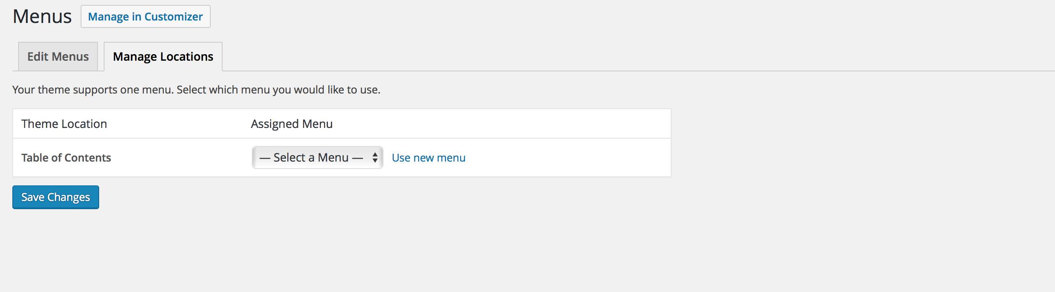**

**Select your new menu and select “Save Changes”**

****